

**SG2000**

EVB Hardware Guide

Version: 1.1

Release date: 2023-12-12

© 2023 Beijing SOPHGO Technology Co.

Revision History

|  |  |  |
| --- | --- | --- |
| **Revision** | **Date** | **Description** |
| 0.1 | 2022/03/23 | Initial |
| 1.0 | 2022/09/13 | Update |
| 1.1 | 2023/12/12 | Update |
|  |  |  |
|  |  |  |
|  |  |  |
|  |  |  |
|  |  |  |
|  |  |  |

Contents

Revision History 2

Contents 3

1 Preface 4

1.1 Overview 4

1.2 Product Version 4

1.3 Readership 4

1.4 Revision History 4

2 Overview 5

2.1 Introductoin 5

2.2 Product Accessory List 5

2.3 Related Components 5

3 Hardware Introduction 6

3.1 Interfaces and Peripheral Hardware 6

3.2 GPIO Configuration 8

4 Operating Instructions 11

4.1 Precautions 11

4.2 HW Config (Boot Device Selection) 13

4.3 C906 and CA53 Switching 14

4.3.1 MIPI Related IO to JTAG I2C Resistors 15

4.4 SD Card Power Enable Polarity Switching 15

4.5 VDDQ Voltage Switching 16

4.6 Refer to the Jumper Connection 16

# Preface

## Overview

Introduction to the SG2000 EVB development board features, hardware characteristics, and peripheral hardware interface configurations.

## Product Version

The EVB development board versions corresponding to this document are listed below.

| Product Name | Product Version |
| --- | --- |
| WEVB-0007A-V01 | SIP DDR3L , V01 |

## Readership

This document (this guide) applies primarily to the following engineers:

* Technical Support Engineer
* Hardware Development Engineer

## Revision History

The revision record accumulates the updated description of each document and the content of the update.

| Revision Date | Releases | Revised Description |
| --- | --- | --- |
| 2022-04-28 | V0.1 | Initial |
| 2022-09-13 | V1.0 | Update |

# Overview

## Introduction

The WEVB-0007A-V01 EVB development board is a validation board developed for the Sophgo SG2000 high-performance AI chip. It is designed to demonstrate the powerful image analysis and computing capabilities of the SG2000 chip, as well as its diverse hardware interfaces. Additionally, it provides customers with a hardware reference design for the SG2000 chip, allowing them to complete the hardware development of their products with minimal modifications.

## Product Accessory List

The list of accessories for WEVB-0007A-V01 EVB development board is as follows:

* WEVB-0007A-V01 EVB Board ×1
* Sensor Board ×1
* AC110V/AC220V to DC12V Transformer
* Support 1.8V/3.3V UART Tool

## Related Components

The following related accessories are not included in the WEVB-0007A-V01 EVB development board package

* Microphone Module
* Wi-Fi module
* Speaker Module
* Panel module

# Hardware Introduction

## Interfaces and Peripheral Hardware

The interface of the WEVB-0007A-V01 EVB board is shown in Figure 3.1.

The interface description of the WEVB-0007A-V01 EVB board is shown in Table 3.1.

 Figure 3.1

Table 3-1

|  |  |
| --- | --- |
| Number | Description |
| 1 | UART0 and UART0_TX trap (VDDIO_EMMC) (default R168=3.3V / R444=1.8V) |
| 2 | See item 33 |
| 3 | Sensor Slot (RX0) (MAIN) |
| 4 | Sensor Clk source (can be provided by the main chip or externally for convenient development of other sensors) |
| 5 | Sensor Slot (RX1) |
| 6 | ADC GPIO (Light Sensor Component Test Interface) |
| 7 | Panel Slot (TX0) |
| 8 | MIC IN (can directly connect electret microphones or external modules) |
| 9 | Audio Out (includes an amplification circuit and can be connected to external speakers) |
| 10 | Internal EPHY |
| 11 | Slave Micro USB port (supports 5V power supply) |
| 12 | USB2.0 |
| 13 | I2S2 (supports AUDIO) |
| 14 | I2S1 (supports AUDIO) |
| 15 | eMMCSPI-NAND, SPI-NOR config (Booting device selection) |
| 16 | Sensor I2C select |
| 17 | RTC battery or supercapacitor |
| 18 | Supports RS485 (SN65HVD01) |
| 19 | DC12V IN |
| 20 | HW Config (PWR_RSTN, PTEST, PWR_ON) |
| 21 | Micro SD card slot (supports SDIO3.0) |
| 22 | Flash socket (can accommodate SPI_NAND/SPI_NOR/eMMC) |
| 23 | On board SPINAND or SPI-NOR |
| 24 | SDIO WIFI Module (1.8V / 3.3 mode) |
| 25 | SD Card SD_PWR_EN polarity selection |
| 26 | GPIO_RTX (CPU_SEL) |
| 27 | USB_ID short to gnd button (used for burning force download button after fast boot) |
| 28 | AUX0 short to gnd button (used for burning force download button after fast boot, typically for QFN packages)   pull up J33 on the side |
| 29 | Power source during battery operation (can also serve as PWR_BUTTON) |
| 30 | PIR socket |
| 31 | Wiegand |
| 32 | CRA = CA53 JTAG (1.8V) MIPI switching requires resistor switching  CVR = RISCV JTAG (1.8V) MIPI switching requires resistor switching  CRR = RISCV JTAG (VDDIO_EMMC, mostly 3.3V)  CVA = CA53 JTAG (VDDIO_EMMC, mostly 3.3V) |
| 33 | R = I2C0 (1.8V) MIPI switching requires resistor switching  V = I2C0 (VDDIO_EMMC , mostly 3.3V) |
| 34 | USB_VBUS_DET (Note that the BGA version. Pin2,3 need to be short first, otherwise pin 1 2 will burn IC) |
| 35 | IR RX socket |

## GPIO Configuration

|  |  |  |
| --- | --- | --- |
| **BALL** | **Substrate Name** | **EVB Net Name&  Default Function Description** |
| C4 | CAM_MCLK0 | SE_CLK |
| C3 | CAM_PD0 | IRCUT_ENA |
| E5 | CAM_RST0 | SensorReset |
| D3 | CAM_MCLK1 | SE_CLK |
| E4 | CAM_PD1 | IRCUT_ENB |
| D4 | IIC3_SCL | Sensor IIC |
| F4 | IIC3_SDA | Sensor IIC |
| L1 | SD0_CLK | SD card |
| L3 | SD0_CMD | SD card |
| L2 | SD0_D0 | SD card |
| K3 | SD0_D1 | SD card |
| M2 | SD0_D2 | SD card |
| M1 | SD0_D3 | SD card |
| K1 | SD0_CD | SD card |
| N1 | SD0_PWR_EN | SD card |
| N3 | SPK_EN | AMP_MUTE |
| M5 | UART0_TX | debug port |
| M4 | UART0_RX | debug port |
| P4 | EMMC_RSTN | eMMC rstn |
| P3 | EMMC_DAT2 | eMMC_data |
| R4 | EMMC_CLK | eMMC_CLK |
| P2 | EMMC_DAT0 | eMMC_data |
| P1 | EMMC_DAT3 | eMMC_data |
| R3 | EMMC_CMD | eMMC_CMD |
| R2 | EMMC_DAT1 | eMMC_data |
| N6 | JTAG_CPU_TMS | debug port |
| N4 | JTAG_CPU_TCK | debug port |
| M6 | JTAG_CPU_TRST | debug port |
| R6 | IIC0_SCL | debug port |
| P6 | IIC0_SDA | debug port |
| P5 | AUX0 | AMP_MUTE |
| M13 | PWR_GPIO0 | LCD_PWM |
| N13 | PWR_GPIO1 | LCD_PWR_CT |
| M12 | PWR_GPIO2 | LCD_RST |
| J13 | IIC2_SCL | External RTC_IIC |
| J14 | IIC2_SDA | External RTC_IIC |
| K15 | UART2_TX | RS485 |
| L15 | UART2_RTS | GPIO |
| K13 | UART2_RX | RS485 |
| K14 | UART2_CTS | RS485 |
| G13 | SD1_D3 | GPIO |
| F14 | SD1_D2 | GPIO |
| H14 | SD1_D1 | GPIO |
| H15 | SD1_D0 | GPIO |
| G15 | SD1_CMD | EPHY_LNK_LED |
| G14 | SD1_CLK | EPHY_LNK_SPD |
| E15 | ADC3 | USB_PT1_EN |
| E14 | ADC2 | USB_PORT_SEL |
| E13 | ADC1 | USB_HUB_Reset |
| A12 | VIVO_D10 | VIVO_DATA |
| B12 | VIVO_D9 | VIVO_DATA |
| C11 | VIVO_D8 | VIVO_DATA |
| B11 | VIVO_D7 | VIVO_DATA |
| C10 | VIVO_D6 | VIVO_DATA |
| B10 | VIVO_D5 | VIVO_DATA |
| D10 | VIVO_D4 | VIVO_DATA |
| A10 | VIVO_D3 | VIVO_DATA |
| A9 | VIVO_D2 | VIVO_DATA |
| B9 | VIVO_D1 | VIVO_DATA |
| E10 | VIVO_D0 | VIVO_DATA |
| C9 | VIVO_CLK | VIVO_CLK |
| B8 | PAD_MIPIRX5N | MIPI_RX |
| C8 | PAD_MIPIRX5P | MIPI_RX |
| B7 | PAD_MIPIRX4N | MIPI_RX |
| A7 | PAD_MIPIRX4P | MIPI_RX |
| C7 | PAD_MIPIRX3N | MIPI_RX |
| A6 | PAD_MIPIRX3P | MIPI_RX |
| B6 | PAD_MIPIRX2N | MIPI_RX |
| C6 | PAD_MIPIRX2P | MIPI_RX |
| B5 | PAD_MIPIRX1N | MIPI_RX |
| C5 | PAD_MIPIRX1P | MIPI_RX |
| A4 | PAD_MIPIRX0N | MIPI_RX |
| B4 | PAD_MIPIRX0P | MIPI_RX |
| A2 | PAD_MIPI_TXM4 | MIPI_TX |
| B3 | PAD_MIPI_TXP4 | MIPI_TX |
| B2 | PAD_MIPI_TXM3 | MIPI_TX |
| B1 | PAD_MIPI_TXP3 | MIPI_TX |
| C2 | PAD_MIPI_TXM2 | MIPI_TX |
| C1 | PAD_MIPI_TXP2 | MIPI_TX |
| D2 | PAD_MIPI_TXM1 | MIPI_TX |
| D1 | PAD_MIPI_TXP1 | MIPI_TX |
| E2 | PAD_MIPI_TXM0 | MIPI_TX |
| E1 | PAD_MIPI_TXP0 | MIPI_TX |

# Operating Instructions

## Precautions

1. The WEVB-0007A-V01 EVB development board is intended for laboratory or engineering development environment.
2. Ensure that the power configuration matches the interface voltage levels.
3. The wiring sequence for the UART0 Debug Port (located at J32) is as follows. Pay attention to the correct order (different from the positive print) to avoid reversing the connections.

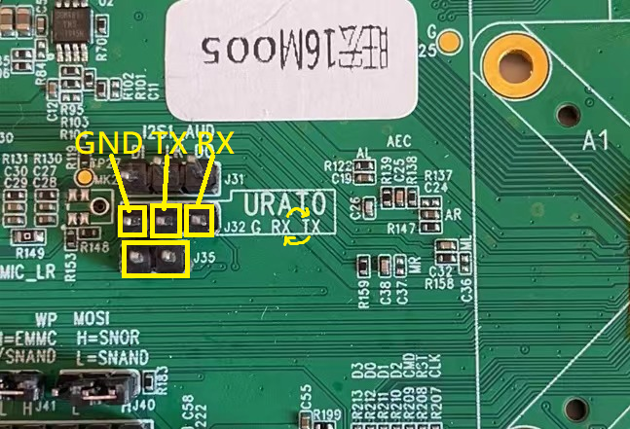

1. Sensor
2. Sensor: The EVB board can only be used for monocular or binocular, a hardware Rework is required for monocular boards to be used for binocular and vice versa.
3. For binocular boards, you can utilize the binocular 307 sensor as a monocular without requiring any hardware rework; software configuration is needed to change from 4Lan Data to 2Lan Data.
4. The monocular sensor board is attached to the J2 connector as shown in the figure below:

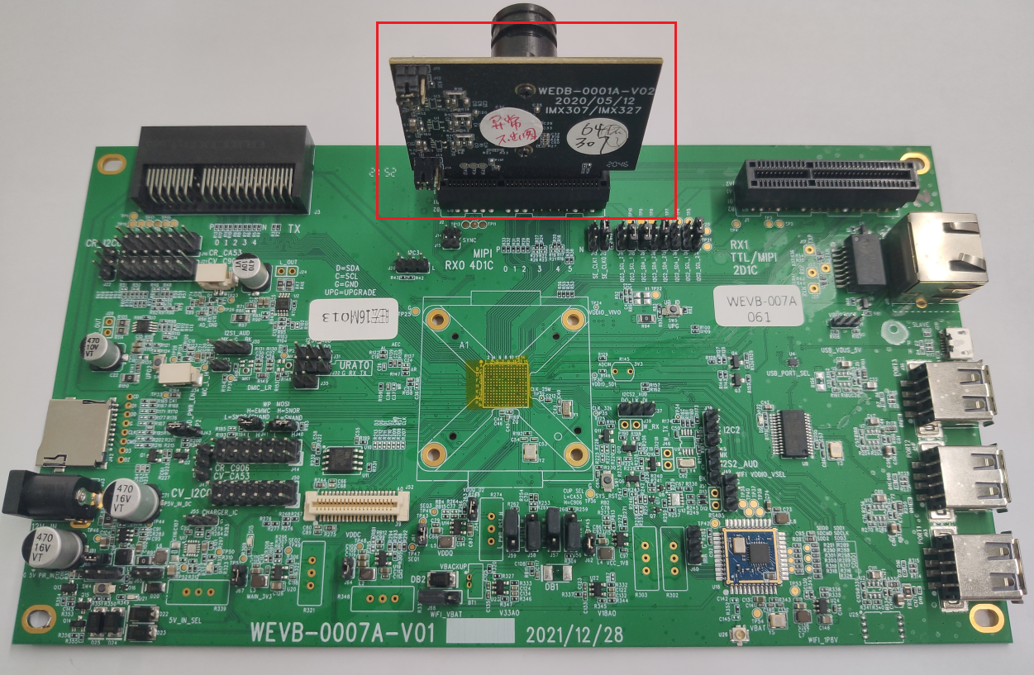

## HW Config (Boot Device Selection)

|  |  |  |
| --- | --- | --- |
|  | **J40**  **EMMC_DAT[0]**  **SPINOR_MOSI**  **SPINAND_MOSI**  **Default pull up** | **J41**  **EMMC_DAT[3]**  **SPINOR_WP_X**  **SPINAND_WP_X**  **Default pull up** |
| Boot from EMMC | Pull up (NC/Jump 1-2 High) | Pull up (NC) |
| Boot from SNOR | Pull up (NC/Jump 1-2 High) | Pull down (Jump 1-2 Low) |
| Boot from SNAND | Pull down (Jump 2-3 Low) | Pull down (Jump 1-2 Low) |

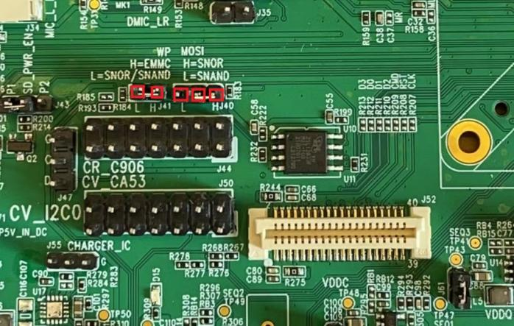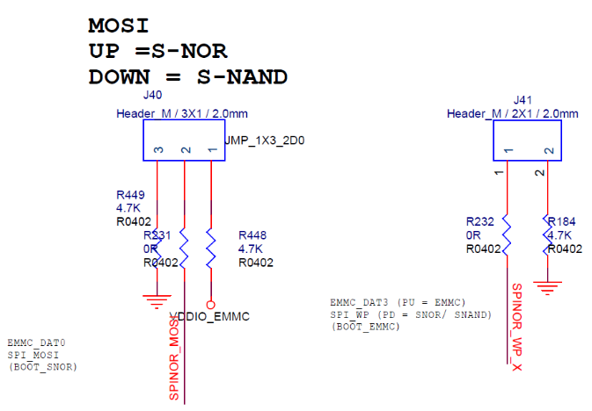

When using the Flash socket, you can use the PU/PD resistor on the daughter board.  
 It is recommended to leave the EVB boot device config jumper unplugged.

## C906 and CA53 Switching

For unsealed chips, you can determine whether it should boot from CA53 or C906B by switching J20.

C906 and CA53 have different JTAG and I2C0 locations, as well as varying voltages.

1.8V (indicated by blue text) on these IO pins corresponds to the shared MIPI pad, and some resistors may require rework.

C906

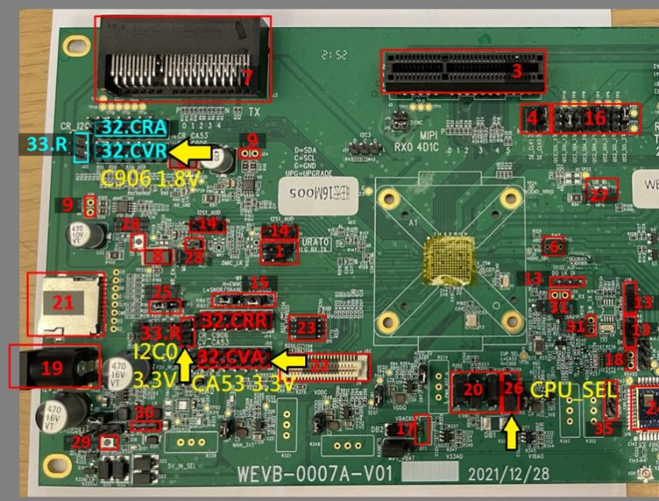 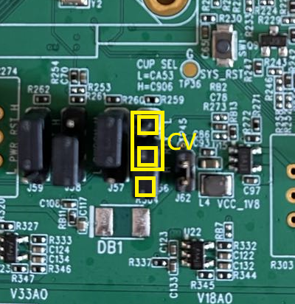

CA53

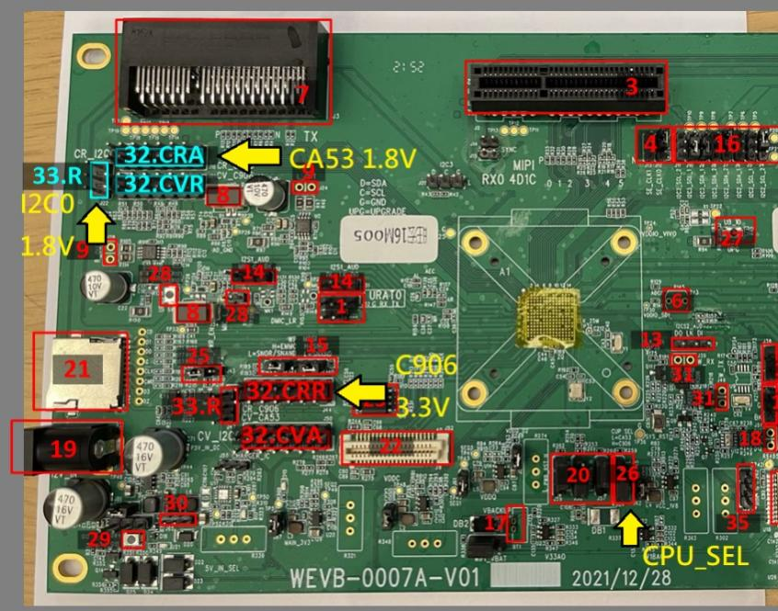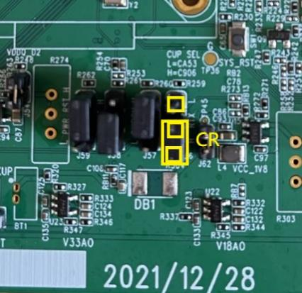

### MIPI Related IO to JTAG I2C Resistors

If you intend to use CA53 (I2C0), some resistors need to be modified for the (RISCV JTAG)/(CA53 JTAG) located in the top-left corner.

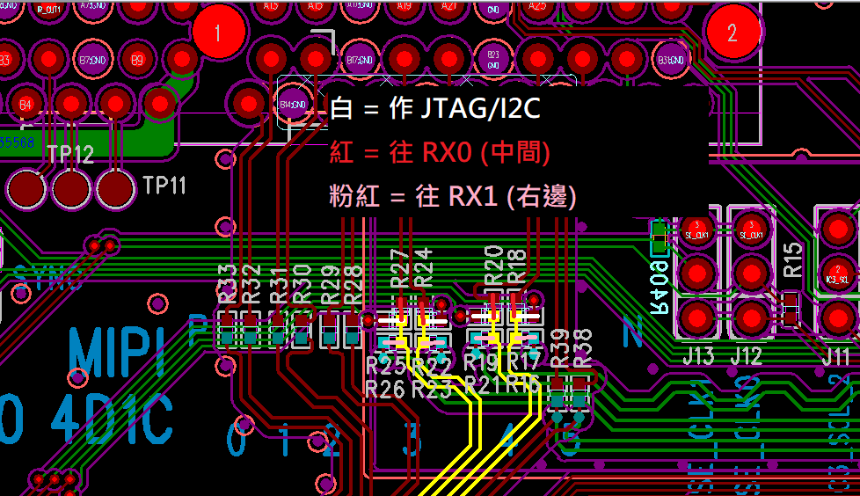

## SD Card Power Enable Polarity Switching

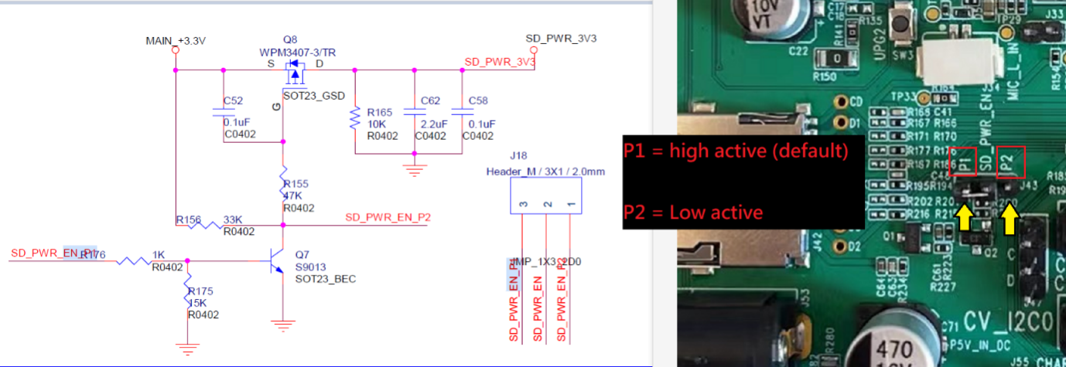

## VDDQ Voltage Switching

SG2000 has built-in DDR3L , VDDQ voltage requires 1.35V.

J54 can be left NC.

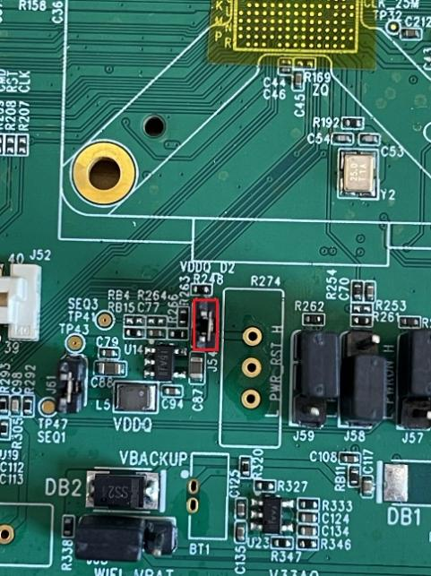

## Refer to the Jumper Connection

